Networking and Linux Tasks Documentation

Task 1: Connect Two Laptops
Connect Laptop 1 and Laptop 2 using a cross-over Ethernet cable or through a switch.
Assign IP addresses:
- Laptop 1: 192.168.1.10
- Laptop 2: 192.168.1.12
Subnet Mask: 255.255.255.0
Verify connectivity using the ping command from each laptop.

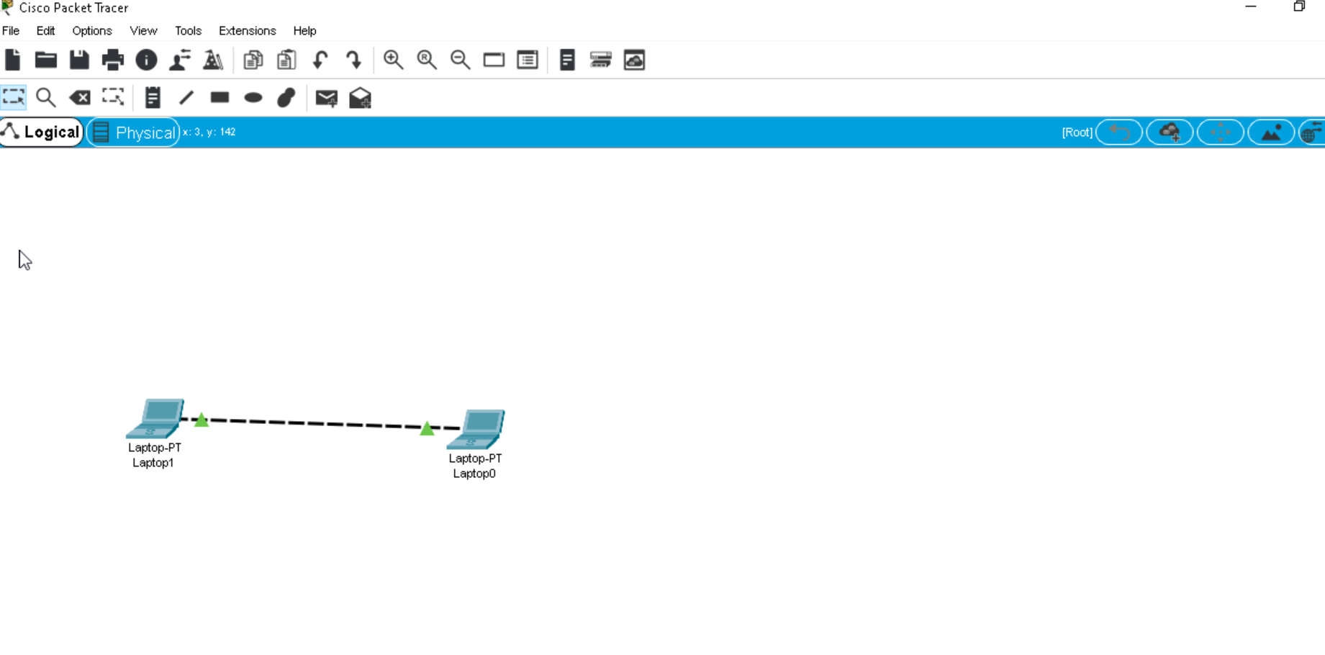
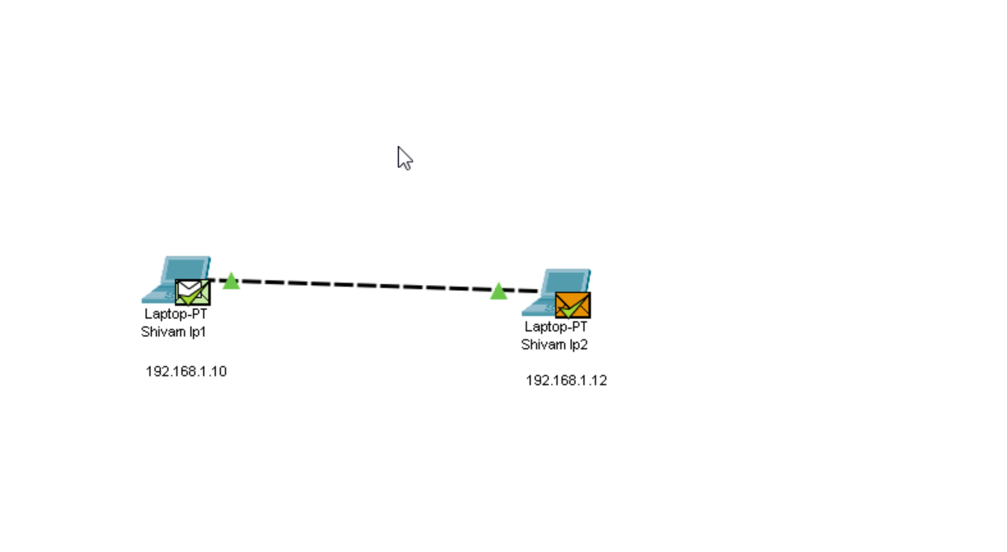
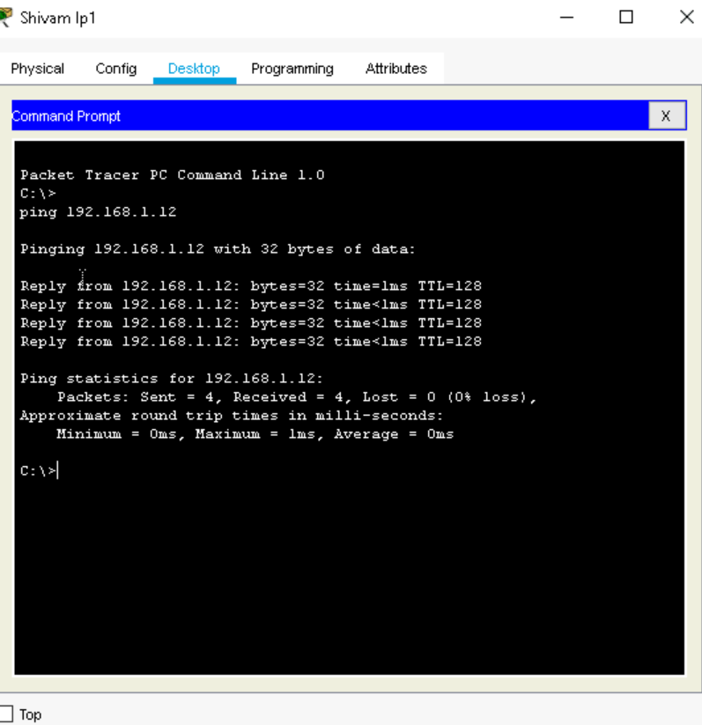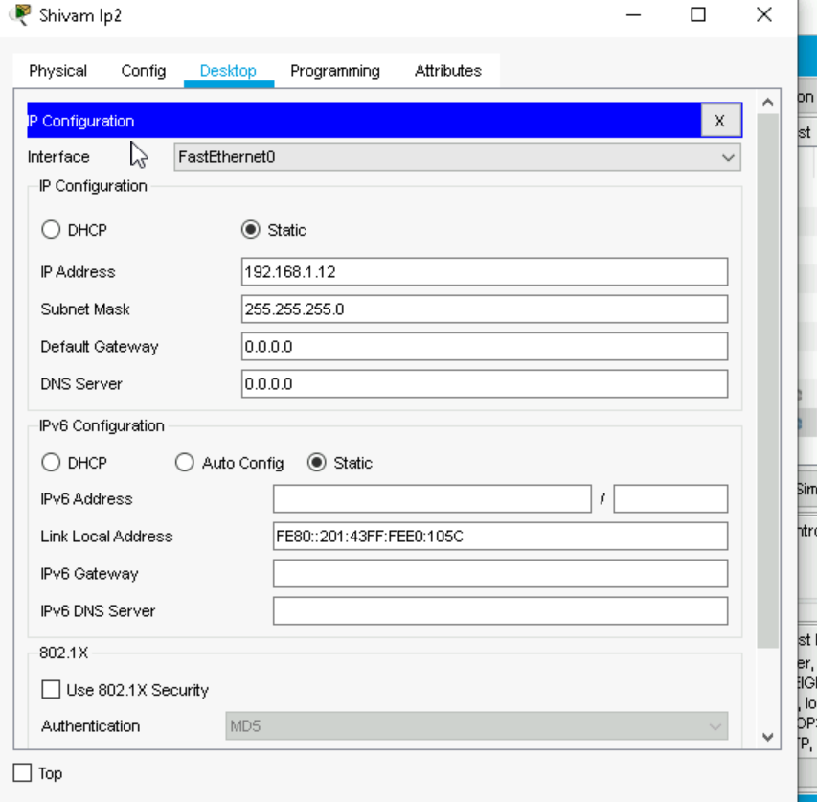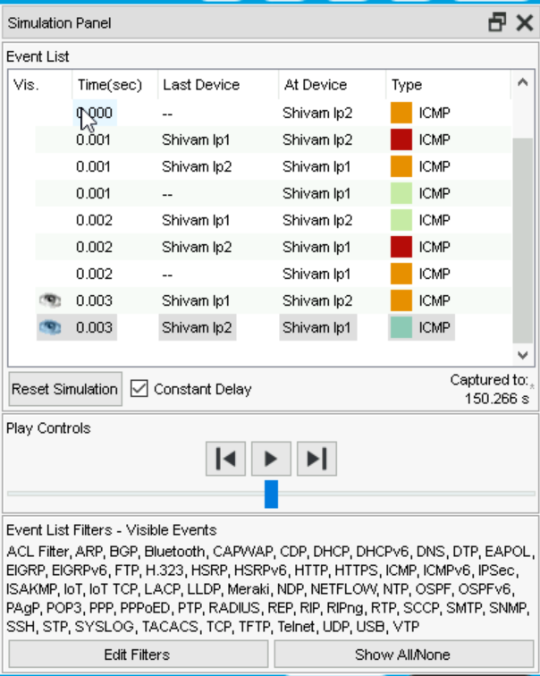

Task 2: Connect 3 Laptops via Switch
Connect all three laptops to a switch using straight-through Ethernet cables.
Assign IP addresses:
- Laptop 1: 192.168.1.10
- Laptop 2: 192.168.1.11
- Laptop 3: 192.168.1.12
Subnet Mask: 255.255.255.0
Test connectivity by pinging each laptop from the others.
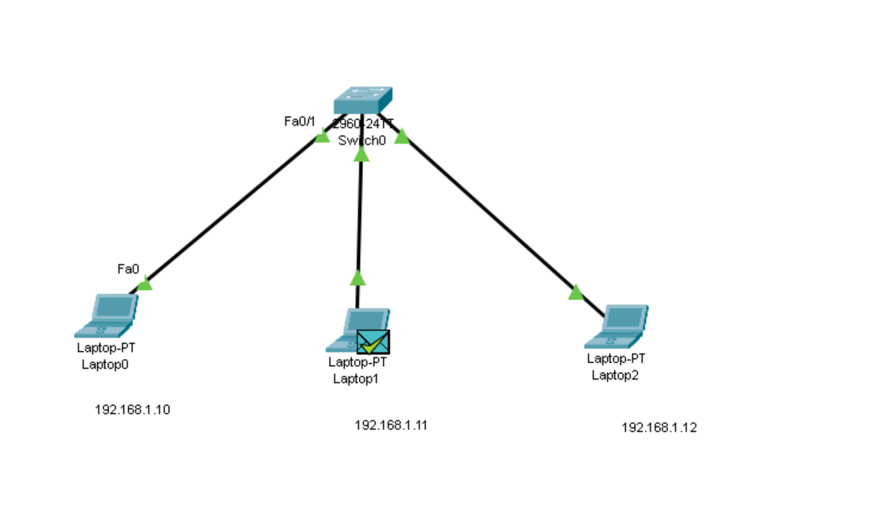

Task 3: Network with 4 PCs and 2 Laptops
Connect all devices to a switch using Ethernet cables.
Assign private IP addresses:
- Dev Team PCs:
* Dev-PC1: 192.168.1.101
* Dev-PC2: 192.168.1.102
* Dev-PC3: 192.168.1.103
- DBA PC:
* DBA-PC: 192.168.1.104
- Tester Laptops:
* Tester-Laptop1: 192.168.1.105
* Tester-Laptop2: 192.168.1.106
Subnet Mask: 255.255.255.0
Label devices accordingly and verify connectivity using ping.
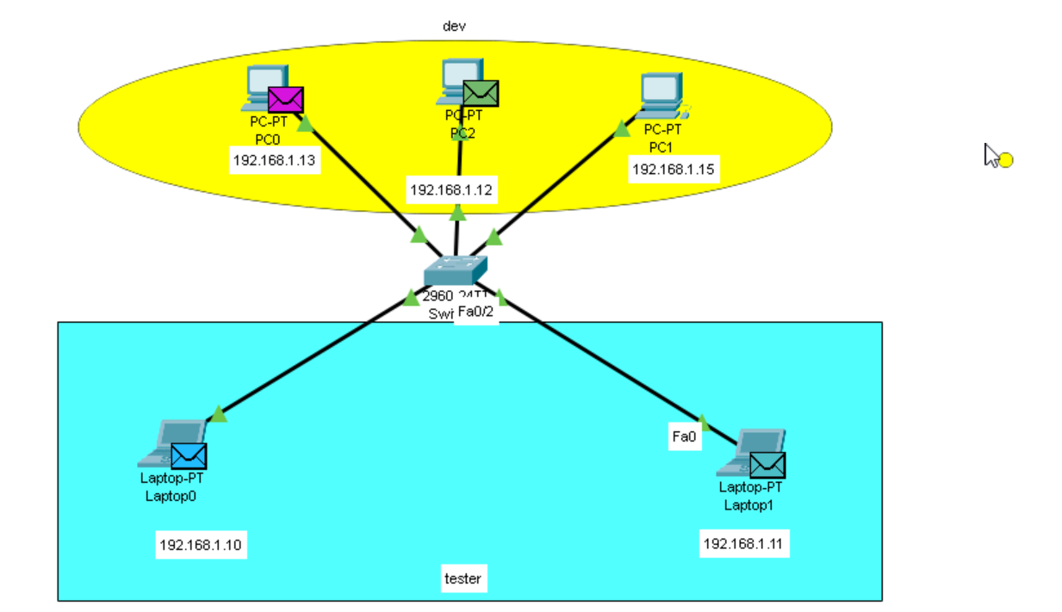

Task 4: Install and Start httpd Service in Linux
Steps to install and start Apache HTTP Server (httpd):
1. Open terminal.
2. Install httpd:
sudo dnf install httpd -y
3. Start the service:
sudo systemctl start httpd
4. Enable service on boot:
sudo systemctl enable httpd
5. Verify installation:
Access http://localhost or http://<IP>
6. Check service status:
sudo systemctl status httpd
